20160302 SRICAM PTZ Secuity Camera With 2x audio through Cell Phones

This is not your standard p2p camera. This is a newer generation that allow you to download an app to communicate with your camera. The browser setup menu is gone (you do not need it).

Pros:

Easy Setup

No router config is required

Can view from Windows 7.0 app (not 8/10).

Works with Android Phone App

Two Way Audio (really)

Imroved opertion.

Cons:

No windows 8/10 app

Some audio delay (not terrible)

Does not work with ISPY

[Link to Specific Camera](http://www.ebay.com/itm/161885080528?_trksid=p2060353.m2749.l2649&ssPageName=STRK%3AMEBIDX%3AIT)

[Link to SRIcam SP012 Site](http://www.sricctv.com/en/products/onvifipcamera/Onvif_IP_Camera_SP012.html)

[SP012 Support Documents](http://www.sricctv.com/en/onlinesupport/forspipcam/)

This version appears to not support ISPY. You register this unit with SRICAM and you do not have to modify your router.

1. Download SRICAM APP to your cell phone and register
2. Tell the camera to connect to your WiFi and you are there.

You can now see your camera from anywhere and listen./alk through the camera. Send email alerts etc.

SRICAM APP Icon is shown here (far right - center).

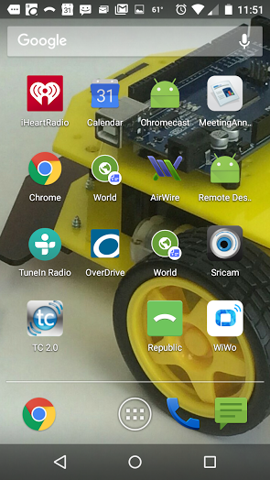

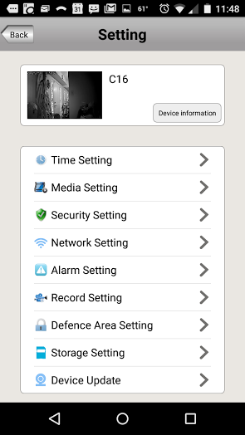

Leave this on Auto (no need to mess with it).

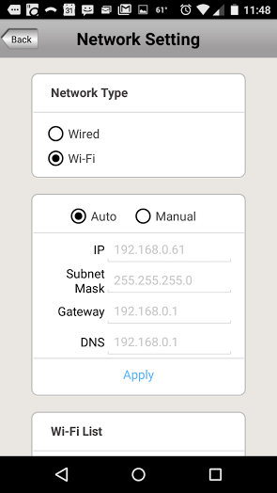

Now you can use the arrow tabs to move your camera left/right + up/down. You listen by default and TALK when you want by holding down the microphone.. (this picture was black and white becase the lights are out (night visiion).

